**Relational SQL Database**

**Kirtana Pathak (kp4hj), Vinh Do (vtd4bc), Liem Budzien (lb7me)**

**Tables**

drawings(imgURL text, username VARCHAR(30), prompt VARCHAR(255), guess VARCHAR (255))

* Holds a URL of the image as a text object, username of the account, prompt from the game, and the final guess, all as VARCHAR’s
* Info is retrieved on the profile page
* Username is a foreign key to the register table
* The primary key is made of every attribute because it is possible that a single user can play the exact same game over again, but with only one differing attribute
* 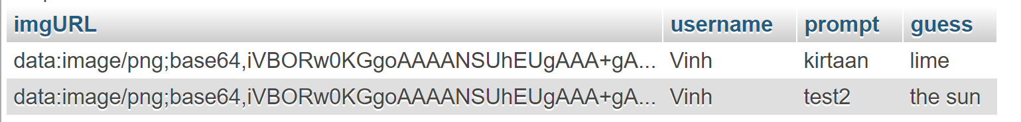

register(username VARCHAR(30), password VARCHAR(30)

* Stores user account information and allows for multiple sessions and for users to come back
* Username and Password cannot be null and must consist of only alphanumeric characters
* Username is the primary key

